The Person in the Preferred Street: Modeling the Interaction of the Urban Environment and Civil Sentiments for Informed Decision Making

Jayedi Aman a, b*, Timothy C Matisziw a, c, d*

*a Department of Geography, University of Missouri, Columbia, MO 65211, USA*

*b Department of Architectural Studies, University of Missouri, Columbia, MO 65211, USA*

*c Department of Civil & Environmental Engineering, University of Missouri, Columbia, MO 65211, USA*

*d MU Institute for Data Science & Informatics, University of Missouri, Columbia, MO 65211, USA*

*a jayediaman@mail.missouri.edu, 0000-0002-6128-8293*

*b matisziwt@missouri.edu, 0000-0003-2159-4904*

*\* Contributed equally*

**Abstract**

*Background:* Understanding the interaction between individuals and the urban streetscape is an essential component of sustainable city planning. Numerous studies have characterized urban environment attributes and spatial dynamics of cities, far less is known about the relationships between aspects of the built environment and public sentiment over different time periods.

*Objectives:* To determine how to construct preferability maps based on public sentiments, as well as what aspects of the urban environment relate to sentiments, and how these relationships change over time.

*Methods:* In this context, a comprehensive framework for predicting preferred streetscape characteristics utilizing deep learning and geospatial techniques is proposed. Geotagged social media posts and street view imagery are employed to account for individual sentiment and geospatial context. Natural Language Processing (NLP) and computer vision (CV) are then used to infer sentiment and model the visual environment within which individuals make posts to social media. An application of the developed framework is provided using Instagram posts and Google Street View imagery of the urban environment. A spatial analysis is conducted to assess the extent to which urban attributes correlate with the sentiment of social media postings.

*Results:* ……………………………………………………………….

*Conclusion:* The findings shed light on sustainable streetscape planning by focusing on the interaction between users and the built environment in a complex urban setting, allowing urban planners and policymakers to make more informed decisions. This opens up a new avenue for research into expanding build environment measurement methods to include perceptions as well as urban environment attributes.

**Keywords**: Urban sustainability; data mining; pedestrian sentiments; transportation behavior, street level imagery; urban environment attributes; Informed decision making

# Introduction

It is increasingly recognized that the linkage between individuals' sentiment and the location(s) associated with sentiment is an important consideration for a variety of informed decision-making tasks, including urban growth, disaster response, humanitarian assistance, and recovery operations (USGIF, 2021). In the event of a crisis, for example, people may find it more beneficial to openly express their feelings about the situation to alert others to potential hazards, harm to human life, or facilities (Luo et al., 2011). During the help and recovery activities, a person can also identify safe or crime-free areas (Sadiq et al., 2020). To that end, urban planning and regulatory agencies are investing heavily in improving the condition of the streets to improve how people experience them. An urban streetscape is the outcome of a complex mixture of multiple environment attributes and is a space through which individuals move in their everyday lives (Benabbou and Lee, 2019; Herrera-Yagüe, et al., 2015). Numerous studies have identified that, the design, condition, and spatial configuration of urban environment attributes such as buildings, traffic infrastructure, and parks can elicit a wide range of collective and individual human experiences (Kaklauskas et al., 2021; Batty et al., 2010). As a result, assessing people's perceptions of urban streetscapes could provide important insights on street semantics, leading to more informed community planning decisions.

Sentiments of an urban environment are psychological perceptions of a city, or a sense of place, which may be a significant factor in how the built environment affects a person's preferences for a particular geographical setting (Larkin et al., 2021). As a result, understanding which streetscapes people prefer and whether the sentiments are influenced by the urban environment attributes has been a crucial step for informed decision-making tasks (Ma et al., 2021; Minou et al., 2020; Yuan et al., 2019). A key problem underlying addressing these questions is the complex spatiotemporal interplay of individual perception, behavior, and multifaceted geospatial context, which makes data collection and analysis process extremely challenging. Attempts to capture individual sentiments have frequently relied on field surveys and voluntary self-report (Jaconsen et al., 2007; Montello et al., 2003; Ben-Akiva and Bierlaire, 1999), while research into the associated urban environment attributes on these sentiments has relied on volunteer workshops, interviews, and questionnaires (Tveit et al., 2018; Choudhry et al., 2015; Hadavi et al., 2015; Ewing et al., 2006). Such methods are typically restricted to small sample sizes over small geospatial contexts and frequently require complex research protocols to ensure their use or applicability across large geographic areas or time periods (Larkin et al., 2021).

In recent times, smart city technologies such as satellite imagery, GPS data, street view imagery, and so on have provided a new opportunity to study large populations' perceptions and spatial dynamics of cities (Ahn et al., 2022). For example, GPS trace data collected with a smartphone has used to reveal previously unknown spatial dynamics such as streetscape desirability analysis (Salazar Miranda et al., 2021; Malleson et al., 2018), relationship between physical activity and land cover (Matisziw et al., 2016), and transportation behavior (Williams, 2020). Sensors and satellite imagery, on the other hand, have been utilized to aid in the assessment and monitoring of challenges such as urban safety (Nadai et al., 2016), conflict zones, and so on (Kurgan, 2013). More recently, street view imagery and social media data have been widely used from a human perspective in different urban studies. While street view imagery has been widely used as a complement to remote sensing imagery for observing visual environment attributes in examining spatio-temporal urban mobility patterns (Zhang et al., 2019), the visual quality of streets (Ye et al., 2019), and walking behaviors (Zhang et al., 2019), social media data has been used for accessibility to public places (Marti et al., 2017) and recreational parks (Hamstead et al., 2022).

Even while these big data-driven computational approaches offer information on a wide range of urban dynamics and processes, far less is known about the relationships between aspects of the built environment and public sentiment over different time periods. This study utilizes a novel geoinformatics methodology that makes use of Street View Imagery (SVI), Location-based Social Media (LSM) data, Geographical Information Systems (GIS), and Machine Learning (ML) approaches to fill this research gap. The purpose of this study is to ascertain: (i) how to construct preferability maps based on public sentiments, as well as (ii) what aspects of the urban environment relate to the sentiments, and (iii) how these relationships change over time. The first stage of the research involves developing a streetscape preferability mapping based on sentiment ranking. To assess preferability, the study combines collected LSM data with a natural language processing (NLP) algorithm. A positive and negative ranking system on social media postings is used to determine whether individuals like or dislike the specific spaces. In the second stage of the study, a variety of urban attributes that urban planners have long-sighted to be connected to how pedestrians experience the city is measured (Gehl, 2013; Jacobs, 1961; Lynch, 1960). Metrics of urban form including visual enclosure (e.g., sky, trees, buildings etc.), human dimension (e.g., roads and sidewalks), and streetscape complexity (e.g., people, cars, bicycles and so on) are constructed utilizing open-source geospatial datasets, such as Google Street View pictures of urban elements, roadways, and CV methods. In order to assess if the metrics affect sentiments over time, a spatial autocorrelation analysis is performed.

The paper makes two major contributions to the literature. The first is methodological in the construction of preferability mapping and associations of urban environment attributes. There have been few studies that integrate urban perception data and street level image composition data approaches to quantify sentiments in the urban contexts (Larkin et al., 2021). Even though studies relied on SVI data approaches have aided in deriving insights to measure the relationship between civil sentiments and the urban environment for large populations (Biljecki and Ito, 2021; Rzotkiewicz et al., 2018), detailed accounts of the use of subjective perception ranking in this procedure are still limited. The MIT Media Lab's Place Pulse project collected 1.5 million crowd-sourced perceptions for over 110,000 SVIs from 2010 to 2015, and devised Computer Vision (CV) algorithms to predict up to 74 percent of the overall of perception similarities among image pairs (Dubey et al., 2016). While Place Pulse locations showed a diverse range of geospatial contexts, the socio-demographics of Place Pulse image ranking participants are unknown (Larkin et al., 2021). As a result, in recent research projects, crowd sourced LSM data has emerged as a valuable resource. The LSM data, combined with SVI, has been used to reveal information and insight in discovering inconspicuous urban places (Zhang et al., 2020), urban function recognition (Ye et al., 2020), urban land use classification (Ye et al., 2020) and Cao & Qiu, 2018), and cognitive sensitivity mapping of urban places (Jang and Kim, 2019). This study extends the exploration by creating a comprehensive framework integrating LSM data, SVI, GIS and ML algorithms to improve the understanding of urban dynamics.

The second contribution of the study is to shine new light on certain urban environment attributes of the urban fabric that can help urban planners and regulatory bodies during the early stages of urban development as well as during urban renewal plans. The majority of the studies are based on the socioecological theory of human behavior, which proposes that urban environment attributes can influence people's individual behavior in cities (Sallis et al., 2012). Research in this context has concerned with identifying urban form metrics; however, evidence for micro-scale metrics of urban form, such as visual enclosure, human dimension, and streetscape complexity, remains mixed (Saelens and Handy, 2008). Visual enclosure measures the amount to which streets are visibly delimited by sky, wall, fence, tree, and building, whereas human dimension evaluates the spatial environment attributes such as sidewalks and their coherence that match the scale and proportion of an individual. Streetscape complexity represents the visual richness of a location which is determined by the diversity and number of environment attributes, such as people, bicycles, minibikes, cars, and streetlights. Previous research projects developed micro-scale metrics measurements, which were found to be strongly related to individual sensual experiences but difficult to quantify (Qiu et al., 2021; Salazar Miranda et al., 2021). To that end, this study investigates which street segments have more or less enclosure, human scale visibility, or complexity, which can be used to compare with preferred locations.

# Methods

The analytical framework used in this paper is depicted in Figure 1. In Phase 1, information that can be used to predict individual sentiment is gathered and processed. In this regard, social media postings are a rich source of data since they can contain texture and tone reflective of an individual's sentiment. Many social media posts include indicators of geographic location (latitude and longitude) as well as temporal references (e.g., date/time stamps). After collecting relevant posts, they can be processed by an NLP algorithm, such as a 'text categorization' technique, to determine the nature of the poster's sentiment. The extent to which spatial dependency among posts along streetscapes can then be assessed using hot spot analyses.

For street segments, metrics of urban form such as enclosure, human dimension, and complexity in determining sentiment are derived in Phase 2. This can be accomplished by analyzing driver/pedestrian-perspective imagery (e.g., Google Street View (GSV)) for a set of POI along city streets. The sky, vegetation, roads, buildings, and sidewalks can then be identified and quantified using computer vision methods including PSPNet and Mask RCNN (Qiu et al., 2021), and GIS was used to derive common built environment exposure variables around image locations. Finally, the sentiment metrics can be used to assess the level of visual enclosure, human dimension, and streetscape complexity. An application to the City of Columbia, MO, USA was examined to demonstrate the analysis framework (Figure 1). Columbia (Figure 2) is a medium-sized city in the midwestern United States with a population of 126,254 that is home to several major universities/colleges (United States Census Bureau, 2020).

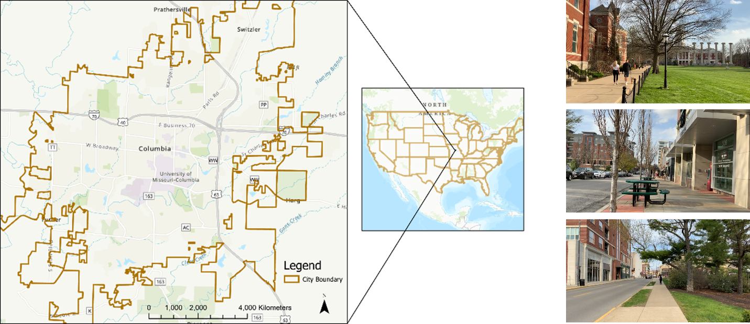

## Location-based Social Media Data Acquisition

In this application, public Instagram posts are used to represent expressions of sentiment toward the city's streetscapes. Previous research initiatives used hashtag-based postings (for example, #Columbiamissouri, #Southboston, #cambridge, and so on) to gather data from Instagram for urban emotion analysis (Kim et al., 2020), and to explore identity-related interpretations in understanding urban identity (Jang and Kim, 2019). While this process has aided in exploring the potential of social media data in urban contexts, some limitations have been identified. First off, most postings lack location information (Latitude/Longitude), which reduces geo-tag accuracy due to users not being present at the specific location. Besides that, a large percentage of posts contain advertisement material that does not accurately reflect the mood of the location. As a result, instead of hashtag-based postings, Instagram platform location-based social media (LSM) data was obtained. Several major city roads were chosen for analysis, and 16 POIs were generated along these roads to aid in the search for nearby Instagram posting locations. As shown in Figure 3, the coordinates of the POIs were then used to search for Instagram posting sites using the instagraphi (https://github.com/adw0rd/instagrapi) Python package.

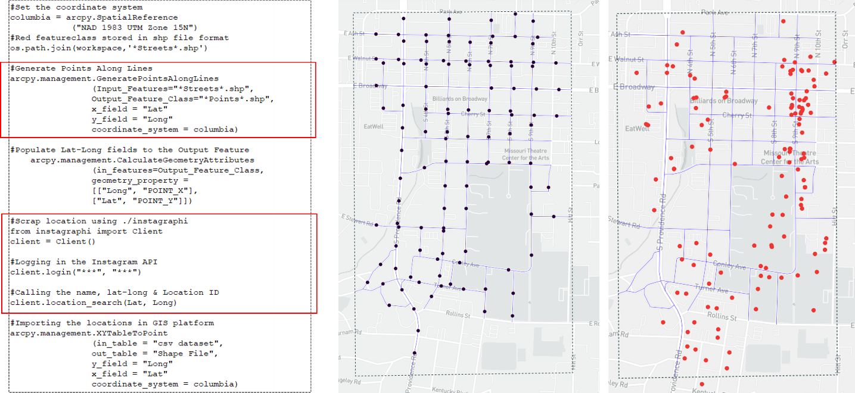

Querying the locations of the 16 POIs resulted in the identification of 135 unique Instagram posting sites in the study region. Relevant social media posts were obtained from InstaLoadGram, a third-party data provider. A total of 111 locations (out of the initial 135 sites) featured usable public posts, yielding a total of 63,861 posts spanning a six-year period (1/1/2015 - 20/11/2021). Figure 4 depicts the data distribution over the time period.

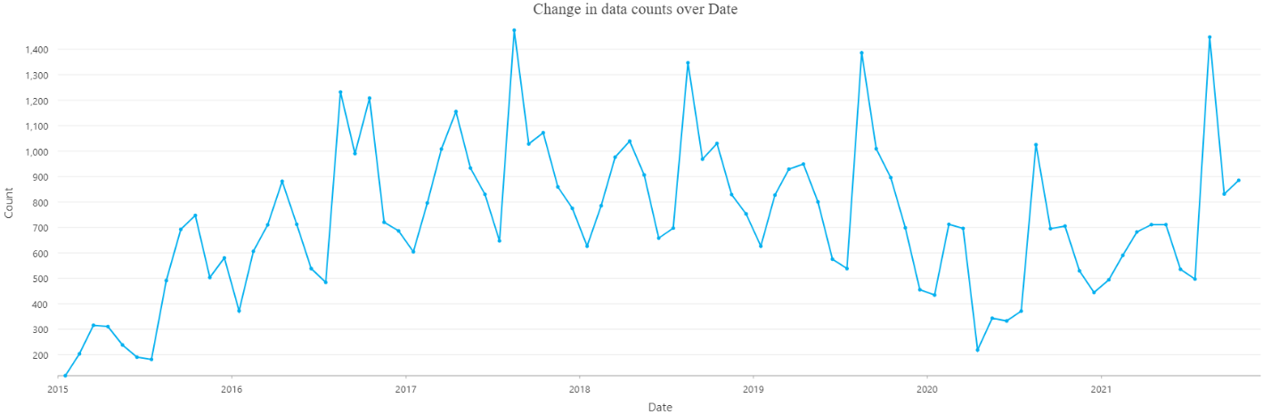

## Sentiment Analysis

Individual sentiment can be inferred using a well-trained NLP model to score text-based posts. For example, 'safe', 'lively', 'bored', 'affluent', 'gloomy', and 'beautiful' are six commonly used sentiment markers. In order to reliably classify post by sentiment, the geotagged postings were processed using a normalized rating system (Zhang et al., 2018). Several deep learning (DL) models were investigated in this respect. Ultimately, the pre-trained Transformers model was selected given its ability to recognize the context giving meaning to each word in the sentence, allowing for more parallelization and shorter training and prediction durations (Colón-Ruiz and Cristóbal, 2020). Specifically, the Hugging Face API, a Bidirectional Encoder Representations from Transformers (BERT) based pre-trained Transformers model, was utilized to predict multilingual sentiment from the Instagram posts given the capacity of BERT to create contextually appropriate word embeddings (Colón-Ruiz and Cristóbal, 2020; Devlin et al. 2019). The model, trained using the BERT approach on one million human evaluations, automatically translates each post into the binary rating ranging (Negative = 0; Positive = 1). an example of which is depicted in Figure 4 (Hugging Face, 2021).

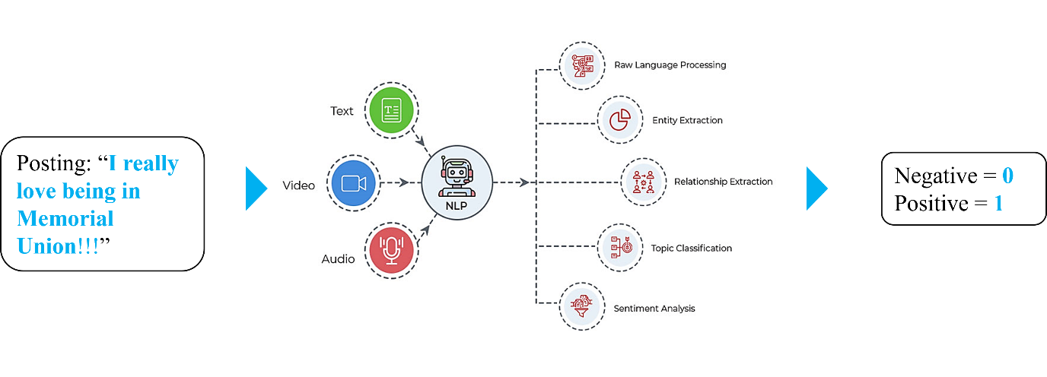

A Getis-Ord Gi* hotspot analysis (Getis and Ord, 1992) for preferability mapping is generated

## Urban Metrics Formulation using SVIs

GSV images were retrieved for spatial feature classification. GSVs provide street-level and profile views of the urban environment and thus represent what individuals navigating the city may encounter. Overall, 341 POIs along roads in the study region were generated to represent locations that would be traversed by individuals. Because the intention was to gather consecutive images of urban features, the POIs were collected at 30-meter intervals and then utilized to retrieve GSV images using Google API (Figure 4 - left panel). Four different viewing perspectives were considered for each POI iεI given the sequence in which the POIs would be traversed along the roads: a) in the direction of the next POI i+1, b) 90.0 degrees from POI i+1, c) 180.0 degrees from POI i+1, and d) 270 .0 degrees from POI i+1 as illustrated in Figure 5 (right panel). Whereas the horizontal field of view was kept at 90.0 degrees, the "pitch" of the returned 800x400 pixel images was set to 0.0 degrees. In total, 1,364 images were retrieved for the sampled POIs.

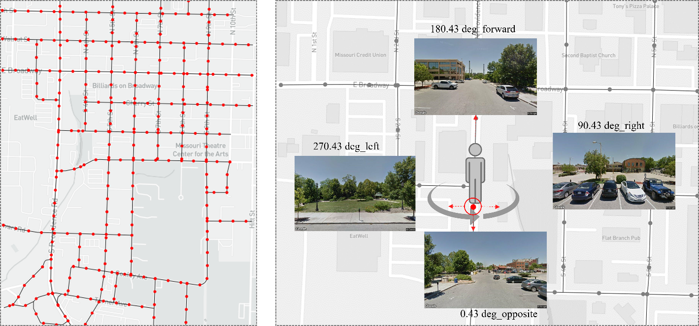

Enclosure, human scale, and complexity measurements are environment metrics thought to be strongly connected to the pedestrian experience but challenging to assess at urban scale (Miranda et al., 2021). Two prominent image detection and semantic segmentation models, PSPNet and Mask R-CNN, were used to classify features in each image. Enclosure and human scale measures were evaluated using PSPNet. The model was trained using the 150-category ADE20k dataset (Miranda et al., 2021). The proportion of an image classified as sky, walls, fences, trees, and buildings was used to represent the level of enclosure that persons were likely to experience. Human scale was estimated as the percentage of an image classified as sidewalk or road. The level of complexity present in the urban environment was characterized as the number of people, bicycles, motor bikes, cars, and streetlights present in each image as computed using the Mask R-CNN (Qiu et al., 2021).

## Spatial Autocorrelation Analysis

Formula of SAR (for statistical analysis)

Standardized Regression Coefficients (src) analysis of lm.beta (impact of individual variables on the sentiments).

# Results

## Preferability Mapping

Computations for the sentiment analysis was performed using the Google Colab Pro platform with a system configuration of Nvidia Tesla P100-PCIE GPU and 16GB RAM. Assessing the sentiment associated with each of the 63,861 postings took 35,756 seconds of computational time. Figure 6 summarizes the proportion of each sentiment classification at each posting site. At many posting sites, a majority of the posts are classified as very positive. There is quite a bit of variation though in the spatial distribution of negative sentiment, with locations having higher proportions of such sentiment located in the Northwest, Northeast, and Central portions of the study region. An hotspot analysis of the proportion of positive postings at each location (Figure 8-right panel) reveals the presence of statistically significant spatial autocorrelation at several sites in the study region. In particular, 19 sites in the South-eastern portion of the region were found to exhibit statistically significant positive spatial autocorrelation at the 0.90 confidence level or above (10 at the 0.95 confidence level or above, 4 at the 0.99 confidence level or above). Two areas to the North were found to exhibit statistically significant spatial autocorrelation of lower proportion of posts classified as positive at the 0.90 confidence level or above (11 at the 0.95 confidence level, 12 at the 0.99 confidence level or above).

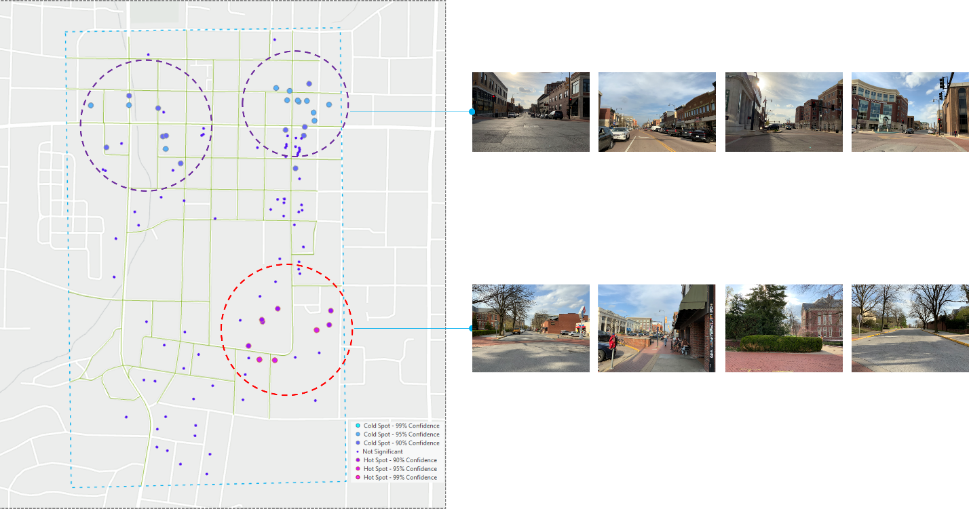

## Relationship between the Urban Metrics features and Sentiments

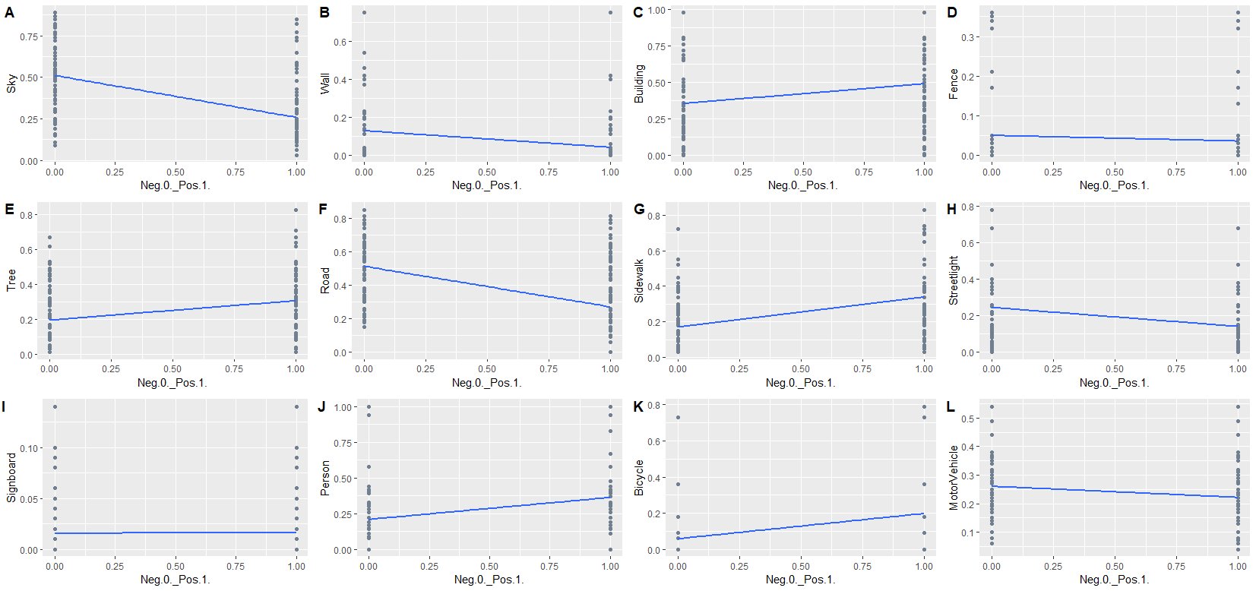

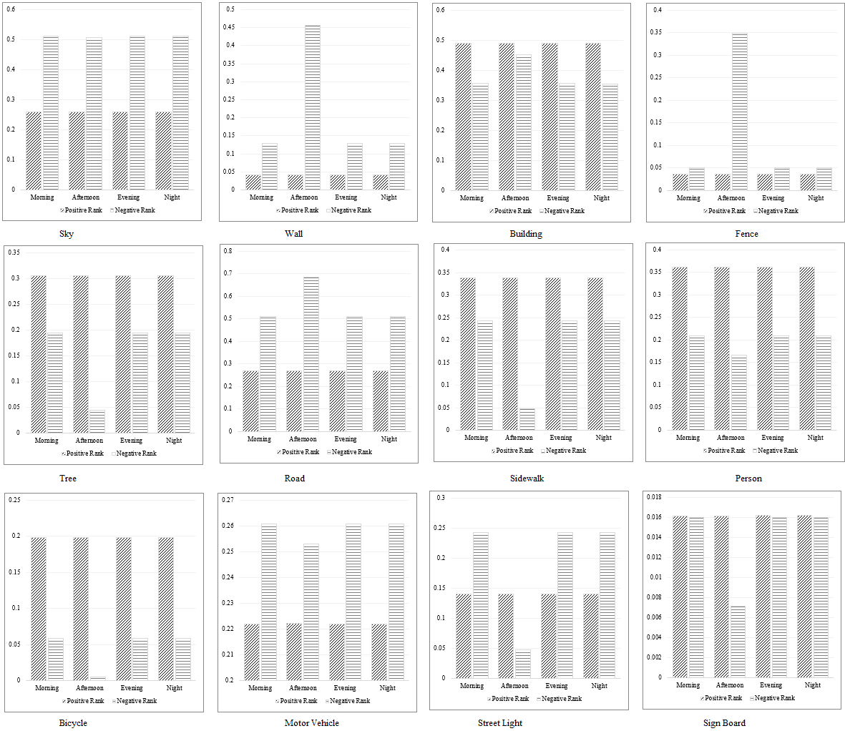

Regression analysis results_Urban Features---Sentiment Ranking

**Jan- April 2021**

|  |  |  |  |  |  |  |  |  |  |
| --- | --- | --- | --- | --- | --- | --- | --- | --- | --- |
| **Urban Metrics** | **Urban Features** |  | ***b*** | ***SEb*** | ***t*** | **Cor. & Sig.** | **Lower Bound** a | **Upper Bound** a | ***β*** |
| Results | Intercept |  | 0.97 | 0.05 | 19.13 | ***p* <.05** | 0.87 | 1.07 | 0.00 |
| Enclosure | Sky |  | -1.18 | 0.05 | -23.17 | -0.57*** | -1.28 | -1.08 | -0.49 |
| Wall | -0.35 | 0.08 | -4.34 | -0.41*** | -0.51 | -0.19 | -0.09 |
| Building | -0.11 | 0.04 | -2.54 | 0.22* | -0.20 | -0.03 | -0.05 |
| Fence | -0.07 | 0.08 | -0.88 | -0.04 | -0.24 | 0.09 | -0.02 |
| Tree | 0.19 | 0.05 | 3.77 | 0.26*** | 0.09 | 0.28 | 0.07 |
| Human Scale | Road |  | -0.17 | 0.05 | -3.37 | -0.48*** | -0.26 | -0.07 | -0.07 |
| Sidewalk | 0.37 | 0.04 | 9.37 | 0.39*** | 0.29 | 0.45 | 0.18 |
| Complexity | Streetlight |  | -0.47 | 0.05 | -9.05 | -0.12*** | -0.57 | -0.37 | -0.15 |
| Signboard | 0.76 | 0.37 | 2.07 | -0.03* | 0.04 | 1.49 | 0.03 |
| Person | 0.27 | 0.04 | 6.43 | 0.32*** | 0.19 | 0.35 | 0.12 |
| Bicycle | 0.24 | 0.03 | 7.08 | 0.26*** | 0.17 | 0.30 | 0.13 |
| Motor Vehicle | -0.07 | 0.07 | -1.08 | -0.11 | -0.20 | 0.06 | -0.02 |

\*\*\**p* < .001, \*\**p* <.01, \**p* <.05

*F(*12, 2120) *=* 191.1, *p<* .001 *and represented a large effect (R2adj* = 0.52*)*

*AIC =* 1344.05, *BIC =* 1423.16

a 95% confidence interval

**May- August 2021**

|  |  |  |  |  |  |  |  |  |
| --- | --- | --- | --- | --- | --- | --- | --- | --- |
| **Urban Metrics** | **Urban Features** | ***b*** | ***SEb*** | ***t*** | **Cor. & Sig.** | **Lower Bound** a | **Upper Bound** a | ***β*** |
| Results | Intercept | 0.89 | 0.04 | 23.11 | ***p* <.05** | 0.81 | 0.96 | 0.00 |
| Enclosure | Sky | -1.45 | 0.04 | -34.59 | -0.66*** | -1.53 | -1.36 | -0.66 |
| Wall | 0.10 | 0.06 | 1.81 | -0.41 | -0.01 | 0.21 | 0.03 |
| Building | -0.18 | 0.04 | -5.06 | 0.33*** | -0.25 | -0.11 | -0.08 |
| Fence | -0.57 | 0.08 | -7.28 | -0.05*** | -0.73 | -0.42 | -0.11 |
| Tree | 0.22 | 0.04 | 6.09 | 0.32*** | 0.15 | 0.29 | 0.10 |
| Human Scale | Road | 0.03 | 0.04 | 0.88 | -0.53 | -0.04 | 0.11 | 0.02 |
| Sidewalk | 0.56 | 0.03 | 18.87 | 0.37*** | 0.50 | 0.62 | 0.29 |
| Complexity | Streetlight | -0.24 | 0.04 | -6.05 | -0.20*** | -0.31 | -0.16 | -0.08 |
| Signboard | 0.15 | 0.31 | 0.49 | 0.03 | -0.46 | 0.76 | 0.01 |
| Person | 0.21 | 0.03 | 6.35 | 0.27*** | 0.14 | 0.27 | 0.09 |
| Bicycle | 0.35 | 0.03 | 10.59 | 0.18*** | 0.28 | 0.41 | 0.17 |
| Motor Vehicle | 0.14 | 0.06 | 2.57 | -0.10* | 0.03 | 0.25 | 0.04 |

\*\*\**p* < .001, \*\**p* <.01, \**p* <.05

*F(*12, 2067) *=* 329.7, *p<* .001 *and represented a large effect (R2adj* = 0.60*)*

*AIC =* 1042.07, *BIC =* 1124.32

a 95% confidence interval

**Sep- Dec 2021**

|  |  |  |  |  |  |  |  |  |
| --- | --- | --- | --- | --- | --- | --- | --- | --- |
| **Urban Metrics** | **Urban Features** | ***b*** | ***SEb*** | ***t*** | **Cor. & Sig.** | **Lower Bound** a | **Upper Bound** a | ***β*** |
| Results | Intercept | 0.92 | 0.05 | 20.29 | ***p* <.05** | 0.83 | 1.01 | 0.00 |
| Enclosure | Sky | -1.42 | 0.05 | -29.46 | -0.64*** | -1.51 | -1.32 | -0.60 |
| Wall | -0.07 | 0.07 | -1.07 | -0.39 | -0.20 | 0.06 | -0.02 |
| Building | -0.06 | 0.04 | -1.35 | 0.31 | -0.14 | 0.03 | -0.03 |
| Fence | -0.57 | 0.08 | -6.85 | -0.12*** | -0.73 | -0.40 | -0.12 |
| Tree | 0.20 | 0.05 | 4.05 | 0.31*** | 0.10 | 0.30 | 0.07 |
| Human Scale | Road | 0.03 | 0.04 | 0.75 | -0.49* | -0.05 | 0.12 | 0.02 |
| Sidewalk | 0.44 | 0.04 | 12.04 | 0.39*** | 0.37 | 0.52 | 0.22 |
| Complexity | Streetlight | -0.42 | 0.05 | -9.04 | -0.12*** | -0.51 | -0.33 | -0.14 |
| Signboard | 0.94 | 0.35 | 2.71 | 0.02** | 0.26 | 1.62 | 0.05 |
| Person | 0.21 | 0.04 | 5.16 | 0.32*** | 0.13 | 0.29 | 0.09 |
| Bicycle | 0.32 | 0.03 | 9.63 | 0.23*** | 0.26 | 0.39 | 0.17 |
| Motor Vehicle | -0.04 | 0.07 | -0.61 | -0.10 | -0.17 | 0.09 | -0.01 |

\*\*\**p* < .001, \*\**p* <.01, \**p* <.05

*F(*12, 2648) *=* 329.7, *p<* .001 *and represented a large effect (R2adj* = 0.58*)*

*AIC =* 1066.33, *BIC =* 1145.09

a 95% confidence interval

**Jan- April 2020**

|  |  |  |  |  |  |  |  |  |
| --- | --- | --- | --- | --- | --- | --- | --- | --- |
| **Urban Metrics** | **Urban Features** | ***b*** | ***SEb*** | ***t*** | **Cor. & Sig.** | **Lower Bound** a | **Upper Bound** a | ***β*** |
| Results | Intercept | 0.93 | 0.06 | 15.62 | ***p* <.05** | 0.82 | 1.05 | 0.00 |
| Enclosure | Sky | -1.19 | 0.05 | -21.84 | -0.48*** | -1.29 | -1.08 | -0.51 |
| Wall | 0.05 | 0.09 | 0.62 | -0.28 | -0.11 | 0.22 | 0.01 |
| Building | -0.13 | 0.05 | -2.67 | -0.53** | -0.23 | -0.03 | -0.06 |
| Fence | -0.62 | 0.10 | -5.94 | -0.02*** | -0.83 | -0.42 | -0.14 |
| Tree | 0.19 | 0.06 | 3.28 | -0.59** | 0.08 | 0.30 | 0.07 |
| Human Scale | Road | -0.18 | 0.05 | -3.45 | -0.38*** | -0.28 | -0.08 | -0.08 |
| Sidewalk | 0.43 | 0.05 | 9.45 | -0.23*** | 0.34 | 0.52 | 0.19 |
| Complexity | Streetlight | -0.35 | 0.05 | -7.06 | -0.11 | -0.44 | -0.25 | -0.13 |
| Signboard | -0.25 | 0.56 | -0.45 | 0.28*** | -1.36 | 0.85 | -0.01 |
| Person | 0.31 | 0.04 | 7.20 | -0.41*** | 0.22 | 0.39 | 0.15 |
| Bicycle | 0.30 | 0.05 | 6.56 | -0.35 | 0.21 | 0.39 | 0.17 |
| Motor Vehicle | 0.07 | 0.08 | 0.80 | -0.54 | -0.10 | 0.23 | 0.02 |

\*\*\**p* < .001, \*\**p* <.01, \**p* <.05

*F(*12, 1671) *=* 142.30, *p<* .001 *and represented a large effect (R2adj* = 0.51*)*

*AIC =* 1136.84, *BIC =* 1212.60

a 95% confidence interval

**May- August 2020**

|  |  |  |  |  |  |  |  |  |
| --- | --- | --- | --- | --- | --- | --- | --- | --- |
| **Urban Metrics** | **Urban Features** | ***b*** | ***SEb*** | ***t*** | **Cor. & Sig.** | **Lower Bound** a | **Upper Bound** a | ***β*** |
| Results | Intercept | 1.00 | 0.06 | 16.30 | ***p* <.05** | 0.88 | 1.12 | 0.00 |
| Enclosure | Sky | -1.34 | 0.06 | -23.93 | -0.42*** | -1.45 | -1.23 | -0.61 |
| Wall | 0.08 | 0.08 | 0.97 | -0.20 | -0.08 | 0.24 | 0.02 |
| Building | -0.23 | 0.05 | -4.71 | -0.67*** | -0.33 | -0.14 | -0.08 |
| Fence | -0.72 | 0.12 | -6.17 | -0.10*** | -0.95 | -0.49 | -0.14 |
| Tree | 0.20 | 0.05 | 3.96 | -0.58*** | 0.10 | 0.30 | 0.09 |
| Human Scale | Road | 0.04 | 0.05 | 0.71 | -0.38 | -0.07 | 0.14 | 0.02 |
| Sidewalk | 0.54 | 0.05 | 11.46 | -0.37*** | 0.45 | 0.64 | 0.24 |
| Complexity | Streetlight | -0.44 | 0.05 | -8.01 | -0.03*** | -0.55 | -0.33 | -0.15 |
| Signboard | 0.25 | 0.37 | 0.66 | 0.00 | -0.49 | 0.98 | 0.01 |
| Person | 0.14 | 0.04 | 3.61 | -0.39*** | 0.07 | 0.22 | 0.07 |
| Bicycle | 0.33 | 0.05 | 6.60 | -0.12*** | 0.23 | 0.43 | 0.15 |
| Motor Vehicle | -0.10 | 0.08 | -1.29 | -0.53 | -0.26 | 0.05 | -0.03 |

\*\*\**p* < .001, \*\**p* <.01, \**p* <.05

*F(*12, 1687) *=* 137.09, *p<* .001 *and represented a large effect (R2adj* = 0.49*)*

*AIC =* 1167.78, *BIC =* 1243.67

a 95% confidence interval

**Sep- Dec 2020**

|  |  |  |  |  |  |  |  |  |
| --- | --- | --- | --- | --- | --- | --- | --- | --- |
| **Urban Metrics** | **Urban Features** | ***b*** | ***SEb*** | ***t*** | **Cor. & Sig.** | **Lower Bound** a | **Upper Bound** a | ***β*** |
| Results | Intercept | 1.18 | 0.06 | 21.11 | ***p* <.05** | 1.07 | 1.29 | 0.00 |
| Enclosure | Sky | -1.35 | 0.05 | -26.81 | -0.30 | -1.45 | -1.25 | -0.58 |
| Wall | -0.42 | 0.09 | -4.78 | -0.35 | -0.59 | -0.25 | -0.10 |
| Building | -0.15 | 0.05 | -3.07 | -0.58 | -0.24 | -0.05 | -0.07 |
| Fence | -0.17 | 0.09 | -1.84 | 0.10 | -0.35 | 0.01 | -0.04 |
| Tree | -0.07 | 0.05 | -1.30 | -0.48 | -0.17 | 0.04 | 0.02 |
| Human Scale | Road | -0.21 | 0.05 | -3.84 | -0.49 | -0.32 | -0.10 | 0.09 |
| Sidewalk | 0.37 | 0.05 | 7.44 | -0.30 | 0.27 | 0.46 | 0.15 |
| Complexity | Streetlight | -0.38 | 0.05 | -7.21 | 0.01 | -0.48 | -0.28 | -0.13 |
| Signboard | 1.39 | 0.35 | 3.92 | 0.07 | 0.69 | 2.08 | 0.08 |
| Person | 0.21 | 0.04 | 4.80 | -0.37 | 0.13 | 0.30 | 0.09 |
| Bicycle | 0.16 | 0.04 | 3.63 | -0.28 | 0.07 | 0.24 | 0.07 |
| Motor Vehicle | -0.15 | 0.07 | -2.26 | -0.52 | -0.28 | -0.02 | -0.04 |

\*\*\**p* < .001, \*\**p* <.01, \**p* <.05

*F(*12, 1975) *=* 154.71, *p<* .001 *and represented a large effect (R2adj* = 0.48*)*

*AIC =* 1434.6, *BIC =* 1512.72

a 95% confidence interval

**Jan- April 2019**

|  |  |  |  |  |  |  |  |  |
| --- | --- | --- | --- | --- | --- | --- | --- | --- |
| **Urban Metrics** | **Urban Features** | ***b*** | ***SEb*** | ***t*** | **Cor. & Sig.** | **Lower Bound** a | **Upper Bound** a | ***β*** |
| Results | Intercept | 1.02 | 0.05 | 21.16 | ***p* <.05** | 0.93 | 1.11 | 0.00 |
| Enclosure | Sky | -1.00 | 0.05 | -21.54 | -0.48*** | -1.09 | -0.91 | -0.44 |
| Wall | -0.22 | 0.07 | -2.99 | -0.16** | -0.36 | -0.07 | -0.05 |
| Building | -0.03 | 0.04 | -0.81 | -0.53 | -0.12 | 0.05 | -0.02 |
| Fence | -0.45 | 0.09 | -4.91 | -0.04*** | -0.63 | -0.27 | -0.09 |
| Tree | 0.16 | 0.05 | 3.48 | -0.56*** | 0.07 | 0.25 | 0.06 |
| Human Scale | Road | -0.22 | 0.05 | -4.78 | -0.44*** | -0.30 | -0.13 | -0.09 |
| Sidewalk | 0.38 | 0.04 | 10.64 | -0.23*** | 0.31 | 0.45 | 0.17 |
| Complexity | Streetlight | -0.45 | 0.04 | -11.87 | -0.06*** | -0.52 | -0.38 | -0.19 |
| Signboard | -0.98 | 0.51 | -1.90 | 0.24 | -1.98 | 0.03 | -0.03 |
| Person | 0.24 | 0.03 | 6.94 | -0.37*** | 0.17 | 0.31 | 0.12 |
| Bicycle | 0.30 | 0.04 | 8.08 | -0.33*** | 0.22 | 0.37 | 0.17 |
| Motor Vehicle | -0.32 | 0.06 | -5.01 | -0.49*** | -0.44 | -0.19 | -0.08 |

\*\*\**p* < .001, \*\**p* <.01, \**p* <.05

*F(*51, 2533) *=* 43.82, *p<* .001 *and represented a large effect (R2adj* = 0.52*)*

*AIC =* 1699.31, *BIC =* 1781.21

a 95% confidence interval

**May- August 2019**

|  |  |  |  |  |  |  |  |  |
| --- | --- | --- | --- | --- | --- | --- | --- | --- |
| **Urban Metrics** | **Urban Features** | ***b*** | ***SEb*** | ***t*** | **Cor. & Sig.** | **Lower Bound** a | **Upper Bound** a | ***β*** |
| Results | Intercept | 0.93 | 0.04 | 20.86 | ***p* <.05** | 0.84 | 1.02 | 0.00 |
| Enclosure | Sky | -1.08 | 0.04 | -25.58 | -0.48 | -1.16 | -1.00 | -0.51 |
| Wall | 0.06 | 0.06 | 0.97 | -0.17 | -0.06 | 0.18 | 0.02 |
| Building | -0.01 | 0.04 | -0.35 | -0.59 | -0.10 | 0.07 | -0.01 |
| Fence | -0.66 | 0.10 | -6.38 | -0.12 | -0.86 | -0.46 | -0.10 |
| Tree | 0.08 | 0.04 | 1.83 | -0.53 | -0.01 | 0.16 | 0.03 |
| Human Scale | Road | -0.14 | 0.04 | -3.33 | -0.35 | -0.22 | -0.06 | -0.06 |
| Sidewalk | 0.42 | 0.04 | 11.66 | -0.30 | 0.35 | 0.49 | 0.17 |
| Complexity | Streetlight | -0.32 | 0.04 | -8.14 | -0.03 | -0.39 | -0.24 | -0.13 |
| Signboard | -1.56 | 0.43 | -3.61 | 0.07 | -2.41 | -0.71 | -0.06 |
| Person | 0.36 | 0.03 | 12.41 | -0.36 | 0.30 | 0.42 | 0.18 |
| Bicycle | 0.35 | 0.04 | 9.57 | -0.07 | 0.28 | 0.42 | 0.16 |
| Motor Vehicle | -0.17 | 0.06 | -2.68 | -0.51 | -0.29 | -0.04 | -0.04 |

\*\*\**p* < .001, \*\**p* <.01, \**p* <.05

*F(*53, 2467) *=* 58.13, *p<* .001 *and represented a large effect (R2adj* = 0.55*)*

*AIC =* 1440.39, *BIC =* 1522.48

a 95% confidence interval

**Sep- Dec 2019**

|  |  |  |  |  |  |  |  |  |
| --- | --- | --- | --- | --- | --- | --- | --- | --- |
| **Urban Metrics** | **Urban Features** | ***b*** | ***SEb*** | ***t*** | **Cor. & Sig.** | **Lower Bound** a | **Upper Bound** a | ***β*** |
| Results | Intercept | 1.01 | 0.05 | 21.53 | ***p* <.05** | 0.92 | 1.10 | 0.00 |
| Enclosure | Sky | -1.06 | 0.04 | -24.94 | -0.40 | -1.14 | -0.97 | -0.48 |
| Wall | -0.04 | 0.06 | -0.65 | -0.32 | -0.17 | 0.09 | -0.01 |
| Building | -0.19 | 0.04 | -4.61 | -0.52 | -0.26 | -0.11 | -0.08 |
| Fence | -0.33 | 0.08 | -3.90 | -0.08 | -0.49 | -0.16 | -0.08 |
| Tree | 0.17 | 0.05 | 3.67 | -0.58 | 0.08 | 0.26 | 0.07 |
| Human Scale | Road | -0.24 | 0.04 | -6.05 | -0.37 | -0.32 | -0.17 | -0.11 |
| Sidewalk | 0.45 | 0.04 | 11.96 | -0.25 | 0.38 | 0.52 | 0.20 |
| Complexity | Streetlight | -0.35 | 0.04 | -9.16 | -0.05 | -0.43 | -0.28 | -0.15 |
| Signboard | -0.63 | 0.51 | -1.24 | 0.22 | -1.63 | 0.37 | 0.02 |
| Person | 0.33 | 0.03 | 9.49 | -0.43 | 0.26 | 0.39 | 0.16 |
| Bicycle | 0.26 | 0.03 | 7.42 | -0.32 | 0.19 | 0.33 | 0.15 |
| Motor Vehicle | -0.17 | 0.07 | -2.30 | -0.56 | -0.31 | -0.02 | -0.04 |

\*\*\**p* < .001, \*\**p* <.01, \**p* <.05

*F(*55, 2257) *=* 35.70, *p<* .001 *and represented a large effect (R2adj* = 0.52*)*

*AIC =* 1399.99, *BIC =* 1480.34

a 95% confidence interval

# Discussion

## Limitation and Future Scope

There are various decision points, constraints, and extensions to this study that might be worthwhile directions for future research. Because of Meta's data policy at the time of the study, the investigators had limited access to social media. Furthermore, the sentiments expressed in the postings may not directly relate to the streetscape in all instances. Further, working with social media postings entails the complex task of interpreting the opinions of multiple individuals. In this study, a pre-trained model was utilized for this task. However, a more target-specific transformers model could be used instead, making use of a large amount of Instagram data, segmenting location-related data, and then training the transformers model for more accurate and relevant sentiment analysis. Given that social media postings are generally accompanied by a time/date stamp, it would also be intriguing to analyze sentiment in a more temporally disaggregated form if more frequent data on urban environment were available.

In the future, real-time social media datasets that incorporate both space and time into analysis, such as Emerging Hot Spot Analysis (EHSA) as a spatiotemporal application of the Getis-Ord Gi* statistical analysis, would be robust and efficient in analyzing urban streetscape. Finally, developing a website-based user-friendly interface for the city residents can be quite beneficial in obtaining real-time responses.

# Conclusion

Making urban human settlements more inclusive, safe, and resilient, as well as encouraging healthy lifestyles and well-being at all ages, are critical to long-term urban sustainability. The way people perceive and value places, infrastructures, and events in their daily lives has far-reaching implications for sustainability planning and implementation efforts. To this end, the aim of this research is to provide vital insights into street semantics to promote more informed community planning decisions (what SDG 11 aims to achieve by 2030). The paper details a framework for linking individual sentiment to characteristics of the streetscape. Open-source social media postings and are processed using deep learning methods to infer sentiment and characterize visibility at locations along a transportation system to make these associations possible. The framework is applied to a small case study to illustrate the procedures involved and demonstrate the applicability of the process.

# CRediT authorship contribution statement

***Jayedi Aman:*** Conceptualization, Methodology, Scripting, Formal analysis, Writing – original draft & editing. ***Timothy C Matisziw:*** Methodology, Software & Scripting, Formal analysis, Writing - original draft, review & editing.

# Declaration of Competing Interest

The authors declare that they do not have any known competing commercial interests or personal relations that could emerge to have influenced the tasks discussed in this article.

# Acknowledgements

The Army Research Laboratory funded the study, which was carried out under Cooperative Agreement Number W911NF-21-2-0276. The views and conclusions expressed in this document are those of the authors and should not be interpreted as representing the Army Research Office's or the United States Government's official policies, expressed or implied. Regardless of any copyright notation herein, the United States Government is authorized to reproduce and distribute reprints for government purposes. Finally, the authors would like to express their gratitude to the MU Graduate Professional Council and ……………………...

# References

Ahn, C., Ignaccolo, C., & Salazar-Miranda, A. (2022). Measuring the City: The Power of Urban Metrics. *Projections*, *16. Measuring the City: The Power of Urban Metrics (MIT Press)*. <https://projections.pubpub.org/pub/xusawg1f/release/3>

Aman, J., Matisziw, T. C., Kim, J. B., & Dan, L. (2022). Sensing Urban Streetscape: Leveraging geotagged social media posts and street view imagery to model urban streetscapes using deep neural networks. *POST-CARBON, Proceedings of the 27th International Conference of the Association for ComputerAided Architectural Design Research in Asia (CAADRIA) 2022*, *1*, 595–604. <https://caadria2022.org/wp-content/uploads/2022/04/167-1.pdf>

Batty, M., Hudson-Smith, A., Milton, R., & Crooks, A. (2010). Map mashups, Web 2.0 and the GIS revolution. *Annals of GIS*, *16*(1), 1–13. <https://doi.org/10.1080/19475681003700831>

Benabbou, R., & Lee, H. (2019). Exploring the evolution of urban emotions in the City of Seoul using social media information. *International Journal of Knowledge-Based Development*, *10*(3), 232–248. <https://doi.org/10.1504/IJKBD.2019.103208>

Ben-Akiva, M., & Bierlaire, M. (1999). Discrete Choice Methods and their Applications to Short Term Travel Decisions. In R. W. Hall (Ed.), *Handbook of Transportation Science* (pp. 5–33). Springer US. <https://doi.org/10.1007/978-1-4615-5203-1_2>

Biljecki, F., & Ito, K. (2021). Street view imagery in urban analytics and GIS: A review. *Landscape and Urban Planning*, *215*, 104217. <https://doi.org/10.1016/j.landurbplan.2021.104217>

Cao, R., & Qiu, G. (2018). Urban Land Use Classification Based on Aerial and Ground Images. *2018 International Conference on Content-Based Multimedia Indexing (CBMI)*, 1–6. <https://doi.org/10.1109/CBMI.2018.8516552>

Choudhry, K. Z., Coles, R., Qureshi, S., Ashford, R., Khan, S., & Mir, R. R. (2015). A review of methodologies used in studies investigating human behaviour as determinant of outcome for exposure to ‘naturalistic and urban environments.’ *Urban Forestry & Urban Greening*, *14*(3), 527–537. <https://doi.org/10.1016/j.ufug.2015.03.007>

Colón-Ruiz, C., & Segura-Bedmar, I. (2020). Comparing deep learning architectures for sentiment analysis on drug reviews. *Journal of Biomedical Informatics*, *110*, 103539. <https://doi.org/10.1016/j.jbi.2020.103539>

De Nadai, M., Vieriu, R. L., Zen, G., Dragicevic, S., Naik, N., Caraviello, M., Hidalgo, C. A., Sebe, N., & Lepri, B. (2016). Are Safer Looking Neighborhoods More Lively? A Multimodal Investigation into Urban Life. *Proceedings of the 24th ACM International Conference on Multimedia*, 1127–1135. <https://doi.org/10.1145/2964284.2964312>

Devlin, J., Chang, M.-W., Lee, K., & Toutanova, K. (2019). BERT: Pre-training of Deep Bidirectional Transformers for Language Understanding. *ArXiv:1810.04805 [Cs]*. <http://arxiv.org/abs/1810.04805>

Dubey, A., Naik, N., Parikh, D., Raskar, R., & Hidalgo, C. A. (2016). Deep Learning the City: Quantifying Urban Perception at a Global Scale. In B. Leibe, J. Matas, N. Sebe, & M. Welling (Eds.), *Computer Vision – ECCV 2016* (pp. 196–212). Springer International Publishing. <https://doi.org/10.1007/978-3-319-46448-0_12>

Ewing, R., Handy, S., Brownson, R. C., Clemente, O., & Winston, E. (2006). Identifying and Measuring Urban Design Qualities Related to Walkability. *Journal of Physical Activity & Health*, *3*(s1), S223–S240. <https://doi.org/10.1123/jpah.3.s1.s223>

Gehl, J. (2013). *Cities for People*. Island Press.

Getis, A., & Ord, J. K. (1992). The Analysis of Spatial Association by Use of Distance Statistics. *Geographical Analysis*, *24*(3), 189–206. <https://doi.org/10.1111/j.1538-4632.1992.tb00261.x>

Hadavi, S., Kaplan, R., & Hunter, M. C. R. (2015). Environmental affordances: A practical approach for design of nearby outdoor settings in urban residential areas. *Landscape and Urban Planning*, *134*, 19–32. <https://doi.org/10.1016/j.landurbplan.2014.10.001>

Herrera-Yagüe, C., Schneider, C. M., Couronné, T., Smoreda, Z., Benito, R. M., Zufiria, P. J., & González, M. C. (2015). The anatomy of urban social networks and its implications in the searchability problem. *Scientific Reports*, *5*(1), 10265. <https://doi.org/10.1038/srep10265>

Hugging face API. (2022). *Hugging face API: bert-base-uncased*. <https://huggingface.co/bert-base-uncased>

Jacobs, J. (1961). *The death and life of great American cities*. Random House, Inc.

Jang, K. M., & Kim, Y. (2019a). Crowd-sourced cognitive mapping: A new way of displaying people’s cognitive perception of urban space. *PLoS ONE*, *14*(6), e0218590. <https://doi.org/10.1371/journal.pone.0218590>

Jang, K. M., & Kim, Y. (2019b). Crowd-sourced cognitive mapping: A new way of displaying people’s cognitive perception of urban space. *PLOS ONE*, *14*(6), e0218590. <https://doi.org/10.1371/journal.pone.0218590>

Kaklauskas, A., Bardauskiene, D., Cerkauskiene, R., Ubarte, I., Raslanas, S., Radvile, E., Kaklauskaite, U., & Kaklauskiene, L. (2021). Emotions analysis in public spaces for urban planning. *Land Use Policy*, *107*, 105458. <https://doi.org/10.1016/j.landusepol.2021.105458>

Kim, E., Rosenwasser, D., & Jose Luis, G. del C. L. (2020). Urban Emotion—The interrogation of social media and its implications within urban context. *Werner, L and Koering, D (Eds.), Anthropologic: Architecture and Fabrication in the Cognitive Age - Proceedings of the 38th ECAADe Conference - Volume 2, TU Berlin, Berlin, Germany, 16-18 September 2020, Pp. 475-482*. <http://papers.cumincad.org/cgi-bin/works/paper/ecaade2020_497>

Kurgan, L. (2013). *Close Up at a Distance: Mapping, Technology, and Politics*. Zone Books. <https://doi.org/10.2307/j.ctt14bs159>

Larkin, A., Gu, X., Chen, L., & Hystad, P. (2021). Predicting perceptions of the built environment using GIS, satellite and street view image approaches. *Landscape and Urban Planning*, *216*, 104257. <https://doi.org/10.1016/j.landurbplan.2021.104257>

Luo, J., Joshi, D., Yu, J., & Gallagher, A. (2011). Geotagging in multimedia and computer vision—A survey. *Multimedia Tools and Applications*, *51*(1), 187–211. <https://doi.org/10.1007/s11042-010-0623-y>

Lynch, K. (2008). *The image of the city* (33. print). M.I.T. Press.

Ma, Y., Yang, Y., & Jiao, H. (2021). Exploring the Impact of Urban Built Environment on Public Emotions Based on Social Media Data: A Case Study of Wuhan. *Land*, *10*(9), 986. <https://doi.org/10.3390/land10090986>

Malleson, N., Vanky, A., Hashemian, B., Santi, P., Verma, S. K., Courtney, T. K., & Ratti, C. (2018). The characteristics of asymmetric pedestrian behavior: A preliminary study using passive smartphone location data. *Transactions in GIS*, *22*(2), 616–634. <https://doi.org/10.1111/tgis.12336>

Martí, P., Serrano-Estrada, L., & Nolasco-Cirugeda, A. (2017). Using locative social media and urban cartographies to identify and locate successful urban plazas. *Cities*, *64*, 66–78. <https://doi.org/10.1016/j.cities.2017.02.007>

Matisziw, T. C., Nilon, C. H., Wilhelm Stanis, S. A., LeMaster, J. W., McElroy, J. A., & Sayers, S. P. (2016). The right space at the right time: The relationship between children’s physical activity and land use/land cover. *Landscape and Urban Planning*, *151*, 21–32. <https://doi.org/10.1016/j.landurbplan.2016.03.006>

Montello, D. R., Goodchild, M. F., Gottsegen, J., & Fohl, P. (2003). Where’s Downtown?: Behavioral Methods for Determining Referents of Vague Spatial Queries. *Spatial Cognition & Computation*, *3*(2–3), 185–204. <https://doi.org/10.1080/13875868.2003.9683761>

Qiu, W., Li, W., Liu, X., & Huang, X. (2021). Subjectively Measured Streetscape Perceptions to Inform Urban Design Strategies for Shanghai. *ISPRS International Journal of Geo-Information*, *10*(8), 493. <https://doi.org/10.3390/ijgi10080493>

Rzotkiewicz, A., Pearson, A. L., Dougherty, B. V., Shortridge, A., & Wilson, N. (2018). Systematic review of the use of Google Street View in health research: Major themes, strengths, weaknesses and possibilities for future research. *Health & Place*, *52*, 240–246. <https://doi.org/10.1016/j.healthplace.2018.07.001>

Sadiq, A. M., Ahn, H., & Choi, Y. B. (2020). Human Sentiment and Activity Recognition in Disaster Situations Using Social Media Images Based on Deep Learning. *Sensors (Basel, Switzerland)*, *20*(24), 7115. <https://doi.org/10.3390/s20247115>

Saelens, B. E., & Handy, S. L. (2008). Built Environment Correlates of Walking: A Review. *Medicine and Science in Sports and Exercise*, *40*(7 Suppl), S550–S566. <https://doi.org/10.1249/MSS.0b013e31817c67a4>

Salazar Miranda, A., Fan, Z., Duarte, F., & Ratti, C. (2021). Desirable streets: Using deviations in pedestrian trajectories to measure the value of the built environment. *Computers, Environment and Urban Systems*, *86*, 101563. <https://doi.org/10.1016/j.compenvurbsys.2020.101563>

Sallis, J. F., Floyd, M. F., Rodríguez, D. A., & Saelens, B. E. (2012). Role of built environments in physical activity, obesity, and cardiovascular disease. *Circulation*, *125*(5), 729–737. <https://doi.org/10.1161/CIRCULATIONAHA.110.969022>

Steen Jacobsen, J. K. (2007). Use of Landscape Perception Methods in Tourism Studies: A Review of Photo-Based Research Approaches. *Tourism Geographies*, *9*(3), 234–253. <https://doi.org/10.1080/14616680701422871>

Tveit, M. S., Ode Sang, Å., & Hagerhall, C. M. (2018). Scenic Beauty. In *Environmental Psychology* (pp. 45–54). John Wiley & Sons, Ltd. <https://doi.org/10.1002/9781119241072.ch5>

United States Census Bureau. (2020). *Census of Columbia* [Data]. <https://data.census.gov/cedsci/table?q=columbia,%20mo&tid=DECENNIALPL2020.P1>

USGIF. (2021, March). Advancing the Interoperability of Geospatial Intelligence Tradecraft with 3D Modeling, Simulation, and Game Engines. *Modeling, Simulation & Gaming (MS&G) Working Group*. Modeling, Simulation & Gaming (MS&G) Working Group, United States. <https://usgif.org/wp-content/uploads/2021/03/USGIF_MSGWG_OGC_Technical_Paper_March_2021.pdf>

Wang, Y., Kotze, D. J., Vierikko, K., & Niemelä, J. (2019). What makes urban greenspace unique – Relationships between citizens’ perceptions on unique urban nature, biodiversity and environmental factors. *Urban Forestry & Urban Greening*, *42*, 1–9. <https://doi.org/10.1016/j.ufug.2019.04.005>

Weijs-Perrée, M., Dane, G., & van den Berg, P. (2020). Analyzing the Relationships between Citizens’ Emotions and their Momentary Satisfaction in Urban Public Spaces. *Sustainability*, *12*(19), 7921. <https://doi.org/10.3390/su12197921>

Williams, S. (2020). *Data Action: Using Data for Public Good*. MIT Press.

Ye, C., Zhang, F., Mu, L., Gao, Y., & Liu, Y. (2021). Urban function recognition by integrating social media and street-level imagery. *Environment and Planning B: Urban Analytics and City Science*, *48*(6), 1430–1444. <https://doi.org/10.1177/2399808320935467>

Ye, Y., Zeng, W., Shen, Q., Zhang, X., & Lu, Y. (2019). The visual quality of streets: A human-centred continuous measurement based on machine learning algorithms and street view images. *Environment and Planning B: Urban Analytics and City Science*, *46*(8), 1439–1457. <https://doi.org/10.1177/2399808319828734>

Zang, P., Liu, X., Zhao, Y., Guo, H., Lu, Y., & Xue, C. Q. L. (2020). Eye-Level Street Greenery and Walking Behaviors of Older Adults. *International Journal of Environmental Research and Public Health*, *17*(17), 6130. <https://doi.org/10.3390/ijerph17176130>

Zhang, F., Wu, L., Zhu, D., & Liu, Y. (2019). Social sensing from street-level imagery: A case study in learning spatio-temporal urban mobility patterns. *ISPRS Journal of Photogrammetry and Remote Sensing*, *153*, 48–58. <https://doi.org/10.1016/j.isprsjprs.2019.04.017>

Zhang, F., Zhou, B., Liu, L., Liu, Y., Fung, H. H., Lin, H., & Ratti, C. (2018). Measuring human perceptions of a large-scale urban region using machine learning. *Landscape and Urban Planning*, *180*, 148–160. <https://doi.org/10.1016/j.landurbplan.2018.08.020>

Zhang, F., Zu, J., Hu, M., Zhu, D., Kang, Y., Gao, S., Zhang, Y., & Huang, Z. (2020). Uncovering inconspicuous places using social media check-ins and street view images. *Computers, Environment and Urban Systems*, *81*, 101478. <https://doi.org/10.1016/j.compenvurbsys.2020.101478>